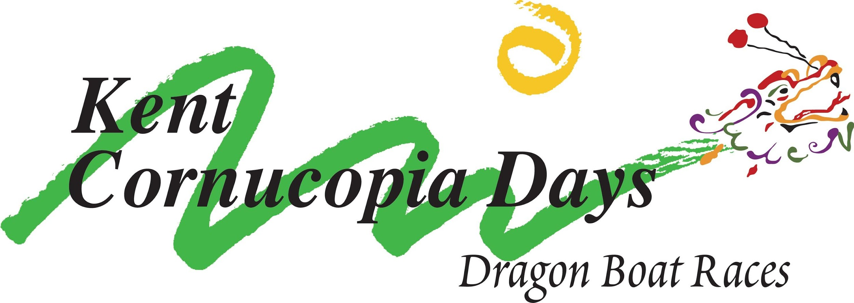

Team Registration
Kent Lions Cornucopia Days Dragon Boat Race Event - July 11, 2020
Lake Meridian - Kent, Washington - 14800 S.E. 272 Street

Entry Fees:
All Mixed & Women’s Teams $650.00 USD
All Mixed & Women’s Canadian Teams $575.00 USD
All Junior Teams $400.00 USD
Specialty Races (requires its own registration) $100.00 USD per event
Community Teams $500.00 USD

Teams that enter after 11:59 pm on June 9, 2020 will be charged a $50.00 ($25.00 for Canadian Team) late fee. No entries will be taken after June 30, 2020 without Directors approval. A $75 cancellation fee will be charged for all cancellations prior to June 30, 2020. Fees are non-refundable after July 1, 2020

Registration: - Either Method Below will work.
- Electronic - click here Active.com
- Manual - Print and complete page 2 below.

Divisions: Women’s, Mixed, Juniors or Community

Specialty Divisions: Mixed Seniors; Women Seniors; Women Cancer Survivors; Open
(Specialty races will only be run if we have 3 teams registered for each division. IF we have more than 4 teams in a Specialty Division, each team's placement in the Specialty Division's final will be based on the cumulative scores from the races run earlier in the day. This is the same way a team's placement is decided for a Mixed or Women's final race.)

- Teams will have 20 paddlers. 1 caller, 1 steersperson, 1-4 alternates. Mixed teams must have a minimum of 10 women and a maximum of 10 men. Senior team members are 40+ years or older. On Open teams all paddlers must be 14 years old or older.
- Team Bracketing will be posted on the web site by July 9th, and a final will be posted the day of the race.
- We will be giving out medals for 1st – 4th place.
- If putting together a Specialty Team from various competing teams, all paddlers must be registered and waivered with a team already registered. You can register and pay for the race on race day.

Other Info: Please bring your own tents. Lake Meridian is an alcohol and drug free zone. Please be courteous of those around you. Registration begins at 7 a.m. Captain’s meeting starts at 8:00 a.m. on race day. First marshalling is at 8:30 a.m. Racing will start at 9:00 am and should be finished by about 4:00 pm.

MAIL-IN REGISTRATION

Team Name: ___________________________________________________________________________

Team Manager: _____________________________ Telephone #: ____________________________

E-mail: __________________________________________(This is where all communications will be sent to. Please let your teammates know you are the contact.)

Team Coach: _________________________________ Telephone #: ____________________________

E-mail: __________________________________________(This is where all communications will be sent to. Please let your teammates know you are the contact.)

Organization/Corporation/Club Affiliation: _____________________________________________________

Team Mailing Address: ___________________________________________________________________

Division: ______________________________________________________________________________

Specialty Division: ______________________________________________________________________

Specialty Division: ______________________________________________________________________

Specialty Division: ______________________________________________________________________

Upon receipt of the team registration, you will get an email from the registrar with additional instructions, including Waiver and Team Roster.

Please make checks payable to: “Kent Lions Dragon Boat Races”

Send check and this completed form to: Kent Lions Club
ATTN: Patty Sikora/Maureen Kisinger
PO Box 5049
Kent, WA 98031

